CSA1606 – DATA WAREHOUSING AND DATA MINING
ACTIVITY : APP BUILDING USING WEKA TOOL

1. Weather-Based Play Prediction ️
Build a WEKA application that predicts whether a person should play outdoors
based on weather conditions.
• Dataset: Outlook, Temperature, Humidity, Windy
• Target: Play (Yes/No)
• Algorithm: J48 Decision Tree
• Tasks:
1. Load the dataset into WEKA.
2. Preprocess the data.
3. Apply J48.
4. Visualize the decision tree.
5. Predict Play for a new weather condition.

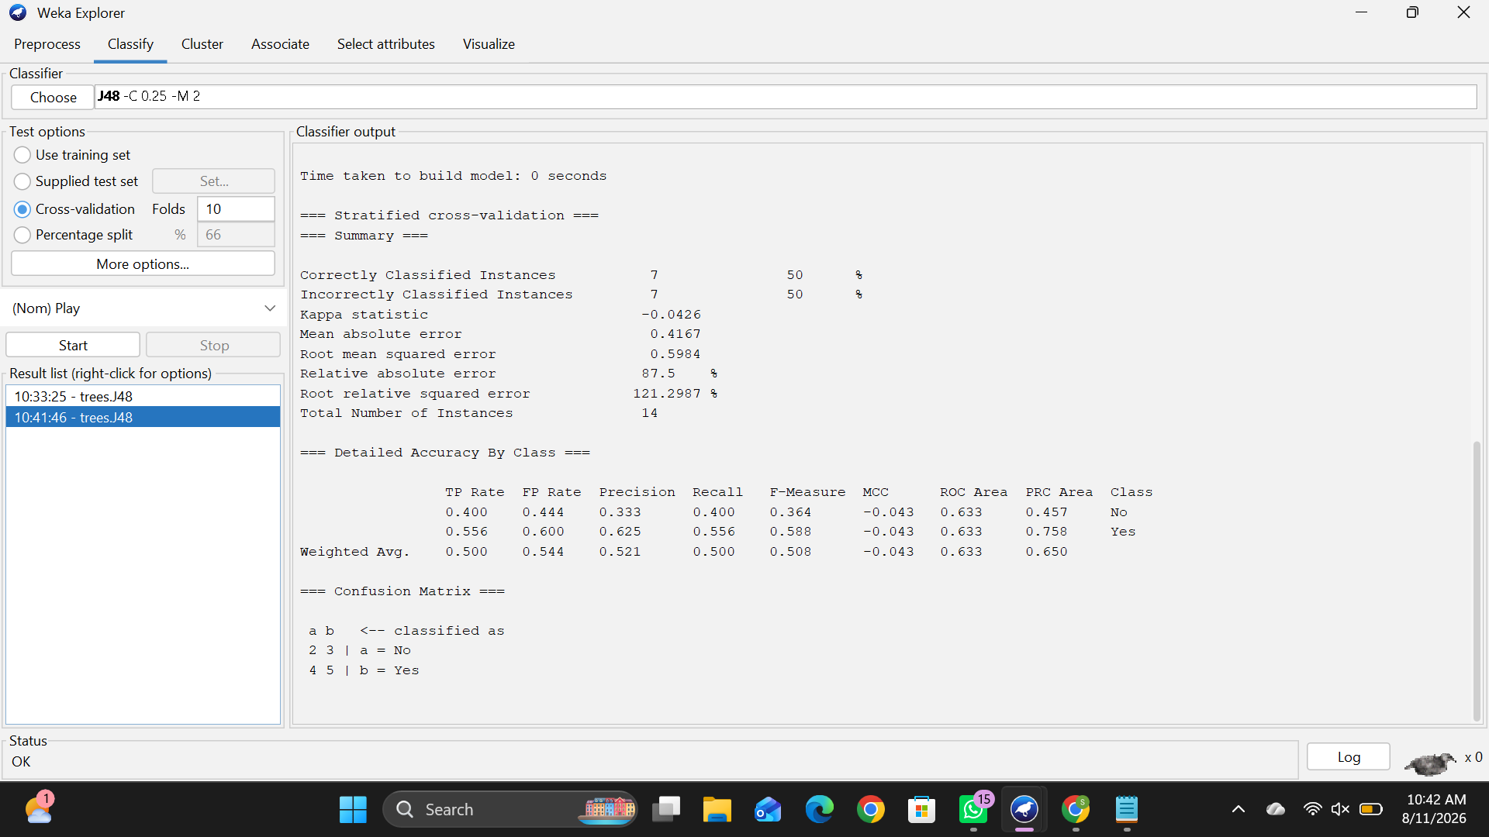

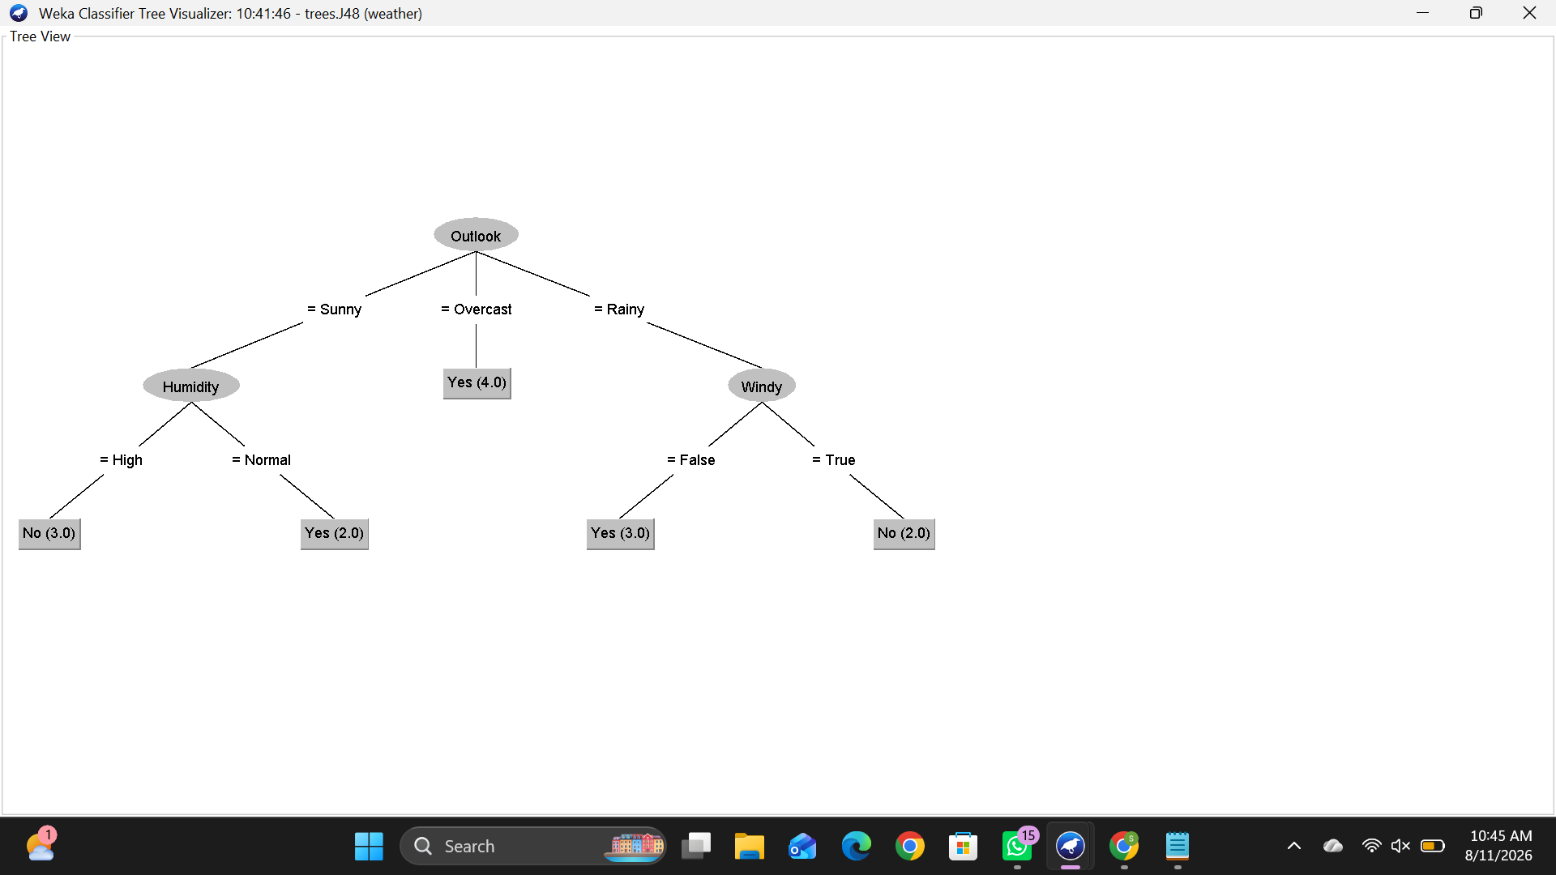

2. Flower Species Classification
Build a WEKA application that identifies the species of a flower from its
physical measurements.
• Dataset: Iris dataset
• Attributes: Sepal Length, Sepal Width, Petal Length, Petal Width
• Target: Iris Species
• Algorithm: J48 or Naive Bayes
• Tasks:
1. Load the Iris dataset.
2. Select the classification algorithm.
3. Train the model.
4. Evaluate its accuracy.
5. Classify a new flower

